Overfishing
Throughout history, the ocean has been one of mankind’s most treasured resources. Providing one billion people with a key source of daily protein, that is 1 in every 7 humans alive on the planet. Fishing was once thought of as a leisure activity, but is now causing serious issues to the marine environment. You would assume that as a society people would be doing everything in their power to help stop overfishing to ensure there will always be a sufficient supply of seafood. Unfortunately, this is not the case. Fisheries today, motivated by greed and an increasing demand for their product, take more and more fish from the world’s oceans, eventually leaving them empty. This harmful and irresponsible practice is called overfishing. Overfishing is devastating to both ecosystems and man-kind.
What is overfishing?
Overfishing occurs when fisherman, industrial fisheries, pirate fishing, and even recreational fishermen catch fish at a rate faster than they can reproduce. Overfishing can lead to depletion of or extinction of fish populations. In 1900 there were at least 6 times more fish than in 2009. Overfishing can also affect marine habitats. The huge mile long nets, that are large enough to fit 13 jumbo-jets, destroy coral reefs and habitats for animals on the sea floor. Not to mention all the un-targeted animals that get caught and killed for no reason. This is called ‘by catch’ and it consists of 8% of total catch. Also, with many species in danger, other species have flourished, causing further imbalance and damage to delicate marine ecosystems. I think overfishing originated when the demands of fish increased globally due to greed and management problems. We have enough fishing boats for 3 earths; do we really need that many boats? It is human nature to want to make as much money as possible. The more fish fishermen catch the more money they get. This caused fisherman to start using bigger and better fishing nets and techniques. Better fishing equipment resulted in overfishing, which is a major environmental issue today. In fact, two men in a row boat about a century ago could catch more fish than some multi-million euro fishing trawlers do today.

Impacts:
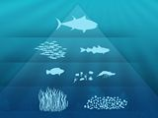
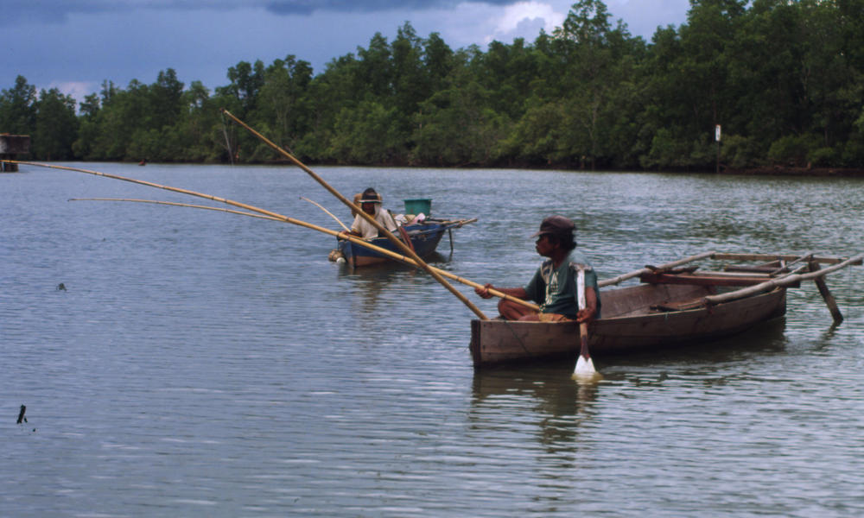
Overfishing and exploitation can devastate an entire marine ecosystem and food chain. Damaging one link of this complex marine food chain, say by overfishing, we could disturb the entire ecosystem. At the base of the chain we have the organisms that create their energy from the sun, such as algae, sea grass and phytoplankton. These animals are referred to as Photo-Autotrophs. The next levels in the food chain are herbivores. They feed off of the Photo-Autotrophs. These animals include parrotfish, and oysters. The next level in the food chain is the small carnivores. These fish are what humans primarily eat. These fish feed on the herbivores. These fish include Snapper, salmon, lobster and sardines. These fish ultimately serve for nourishment for bigger, faster predators. The top predators on this food chain are sharks, tuna and seal. Overhunting of herbivores results in uncontrolled growth of algae and seaweeds, which smothers corals and other bottom-dwelling organisms. This would also cause the marine food chain to collapse. Unsustainable fishing techniques reduce fish stocks throughout the ocean. Highly-fished top predators are starting to disappear because there are no fish stocks for them to eat; this drastically alters the food web. Overall, the mortality of target fish from the ocean, as well as by-catch and the increased discards of fish that enter the ocean as food, can change food web dynamics and cause ecological shifts that further reduce biodiversity and productivity. A quote from Dr. Daniel Paul, professor and Director of the University of British Columbia’s Fisheries Centre said “The big fish, the bill fish, the groupers, the big things will be gone. It is happening now. If things go unchecked, we’ll have a sea full of little horrible things that nobody wants to eat. We might end up with a marine junkyard dominated by plankton”. Besides damaging the marine ecosystem, overfishing and exploitation can also impact human livelihood and sustainability. Many Pacific societies, particularly those in Southeast Asia, Central America and the South Pacific islands, depend on tourism and commercial fishing for daily survival. These communities suffer when locals need more efficient supplies. Overfishing may cause loss of fishing activity, reduced income and an insecure food supply. Habitat destruction worsens overfishing by reducing fishable area and productivity. Overfishing and exploitation also affect tourism. For example damaged coral reefs can discourage popular recreational activities such as snorkeling. Marine scientists now think that overfishing is a bigger threat to the ocean environment than pollution.

By catch:
By catch is when fisheries catch other fish or organisms unintentionally, and in most cases get thrown back into the ocean dead. Some creatures that are caught are turtles, dolphins, birds, untargeted fish, sharks, starfish and whales. Shrimp is a prime example of by catch. For every kilo of shrimp landed, over 3 kilos of tropical marine life is caught and dies. Shrimp fishing accounts for between 3 and 4 per cent of the world’s fishing industry, but is responsible for over 27 per cent of the unnecessary destruction of marine life. By catch is a major problem for the fishing industries because dealing with the untargeted fish wastes valuable resources and time. One the positive side there have been technologies invented to help reduce by catch. Turtle elimination devices are used in some shrimp fisheries to avoid killing turtles. The process of setting the hooks can be changed and bird-scaring devices drastically cut the numbers of birds killed. To avoid dolphins being caught in nets other devices can be used. Pingers are small sound-emitting devices that are attached to nets, but they are not always effective. Escape hatches (consisting of widely spaced metal grids, which force the creature up and out of the net) have also been used. Although these devices may have a role to play, they cannot address the whole problem. These devices require constant monitoring and maintenance. Realistically these devices will probably only be used in areas with well-developed fishery management and enforcement agencies. Even with technology advancements, by catch is still widely recognised as one of the most serious environmental impacts of modern commercial fisheries.

How Can We Stop Overfishing?
Depletion of the fish population is a problem that could be managed. Even though, it is difficult for the depleted stocks to return to sustainable levels, it is possible to recover. A management and sustainment plan I think would benefit this overfishing. The government should set strict rules with serve consequences. I feel like the government isn’t doing enough or doesn’t really care about overfishing. Did the government put overfishing on the back burner because they have to many bigger problems to deal with? This is why I think someone needs to step up and get the message out and educate people on the issue of overfishing, so people know how big of a deal it really is. Rules should also be set in like putting a limit on the amount of fish fishermen can catch in a certain amount of time, restrict some areas of the ocean against fishing, and set rules that fishermen must follow when fishing. Overfishing is a major issue all over the world, not just in a few locations; therefore we must educate everyone about the depletion of fish due to overfishing. The next step would be to put restrictions on certain areas of the ocean where fish could reproduce and have time to grow. This area would give fish time to reproduce without fishermen taking them out of the ocean before they have the chance to multiply. With everyone aware of the issue, and doing little things that help, will help stop overfishing before its too late.
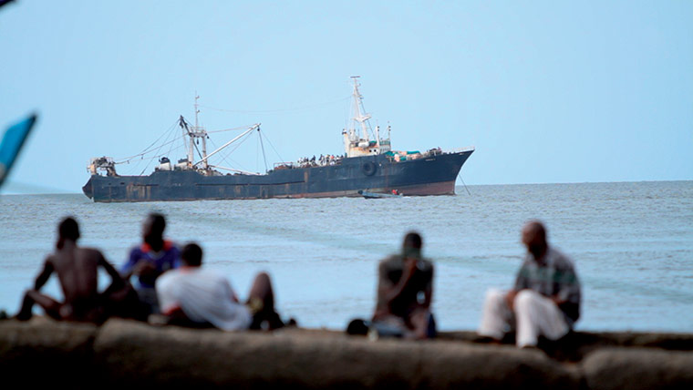
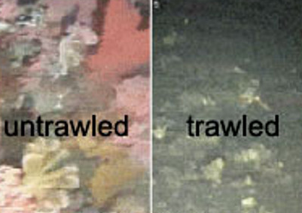
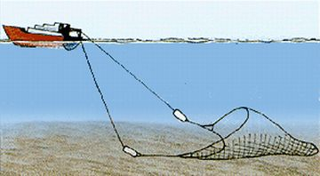
Pirate fishing:
Pirate fishing, also known as illegal, unreported and unregulated fishing, leaves communities and villages without much needed food and income and the marine environment damaged and destroyed. In 2001, Greenpeace estimated there were at least 1,300 industrial scaled pirate fishing ships at sea. From the worlds coast to coast, these pirate fishermen are netting in millions of dollars which rightfully belongs to the local communities. The United Nation estimates that Somalia loses $300 million dollars a year due to pirate fishing; Guinea loses US$100 million. Globally more than US$4 billion is lost each year. Chances are you have probably eaten an illegally caught fish in your life. The fish that the illegal fishermen catch are transferred to factory ships, mixed with legally caught fish then sold in legitimate ports. Governments around the world do little to check or try to stop pirate fishing. They do little to investigate what has landed in their own port, despite the various international commitments and plans. On the other hand, countries that are usually the victims of pirate fishing are the countries that can’t afford to enforce the law in their own waters. Around 80 different countries play host to pirate fishermen- including the European Union and Taiwan, Panama, Belize and Honduras. International enforcement could shut down this trade if they chose to. Pirate fishermen use techniques that destroy ocean life. They typically fish off radar of any officials or other boats. Tuna stocks around Tanzania, Somalia, and Papua New Guinea are typically their main targets. They use huge nets that scoop up entire shoals, including young fish that are vital for breeding and future stock growth. Fish that won’t make money on the fish market, but could still provide food for others, or thrown back into the ocean dead. Harmful methods illegal fisheries use is trawling, which means to drag huge nets across the ocean floor. Trawling results in large amounts of by catch. Fishermen use two different methods of trawling; bottom- trawling and demersal trawling. Bottom-trawling is when a boat tows fishing nets along the sea floor resulting in destruction of marine habitats, as well as forcing everything into the nets. Demersal trawling is when boats tow a net just above the benthic zone (which is just above the sea floor). Trawling nets are held open by a pair of trawling doors dragged along the sea floor, which can weigh up to 5 tons each. The other very harmful method pirate fishermen practice are dredges, which are metal frames with attached bags, and are used to catch species living in the sand. This not only results in by catch but it damages the surface of the ocean as well. Pirate fishing can be stopped. Governments can outlaw flags that trick officials, and refuse entry to fishing and supply vessels. It is a matter of someone standing up and taking control.
Overfishing is one of the largest environmental problems we are currently facing, due to potential effects on the global economy, and its frightening destruction of the oceans’ ecosystem. Overfishing’s effects can never be reversed. However, the question remains; will we join together and do something about overfishing, or will we ignore the facts and have to deal with the life- threatening consequences that come from overfishing?

“Overfishing” See the Sea. Wednesday 12 December 2010
“Greenpeace/ By catch” August 2009
“overfishing” StudyMode.com 06,2008
“Greenpeace.com/ pirate fishing” August 2009
“Greenpeace.com/ pirate fishing” August 2009
“fishing methods” Monterey Bay Aquarium Bibliography "Overfishing by Yuliya_miryana_bedros." Overfishing by Yuliya_miryana_bedros. N.p., n.d. Web. 23 Jan. 2013. "Latest Articles." Overfishing. N.p., n.d. Web. 23 Jan. 2013. "The Ocean." National Geographic. N.p., n.d. Web. 23 Jan. 2013. "Common Menu Bar Links." Canada's Actions. N.p., n.d. Web. 23 Jan. 2013. "Overfishing." Overfishing. N.p., n.d. Web. 23 Jan. 2013.

